World Service Office CEA-HOW, Inc.
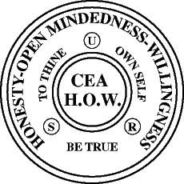

3371 Glendale Boulevard, Suite 104 Los Angeles, CA 90039
Phone: 323-660-4333
Email: gso@ceahow.org

Compulsive Eaters Anonymous - HOW
Board of Directors July 22, 2022
Final Meeting of 2021-22 Board

Susan M. called the meeting to order at 4:13 with the Serenity Prayer.

Roll call was taken.
Board and Officers present: Susan M. (Chair), Lorraine S. (Vice-Chair), Bryce M., Gris M., Adell P., Aneisa B., Mary Q., Marcus F. (Non-participating Director); Corporate officers, Michael D (President) Carolyn P. (Treasurer), David M. (Secretary); Executive Director: Ellie M. Not Present: Janice R.
Guests present: Jose F., Donna T. Maria D. as translator.

Chair entertained a motion to approve the minutes of the special Board of Directors meeting, 6/25/2022. Lorraine S. moved to approve the minutes. Aneisa B. seconded. Motion passed unanimously.

Carolyn gave a brief treasurer’s report that early bird registration for Global Convention 2023 was raised to $290 from $280 because of inflation.

Susan reviewed the Board Action Items list and marked which items were completed. The remaining four items would be carried forward to the new Board Action Items list. The discussion on the Board working group on literature pricing and distribution will be carried forward to next year’s Board agenda.

Susan acknowledged all who had served during the year and especially those who were leaving the Board: Board members, Susan M. and Janice R.; and Corporate Treasurer, Carolyn P.

Meeting adjourned at 4:23 pm.

